University of Engineering and Technology, Lahore
Name: Maria Abbas
Reg No: 2026(S) CYS_61
Department: Computer Engineering
Degree: Cyber security
Section: B
Assignment: PF Lab week 11
Date: 18 May 2026
CLO4

Lab Tasks
Exception Handling
Task 1:
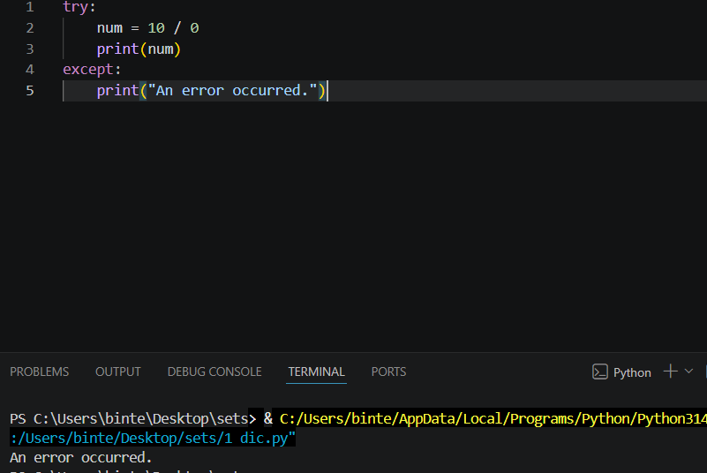
Task 2:
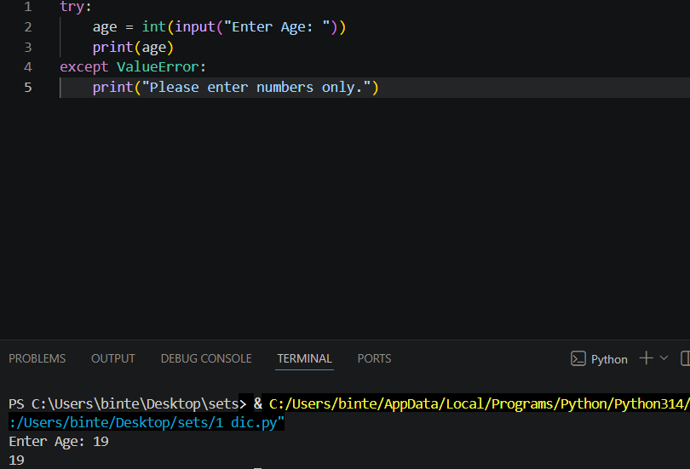
Task 3:
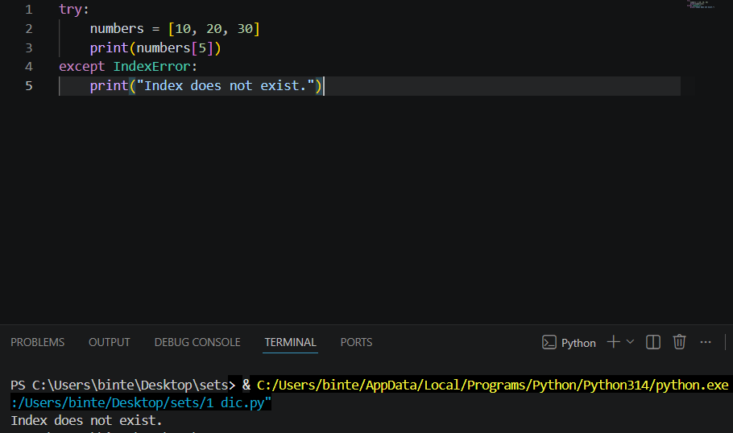
Task 4:
